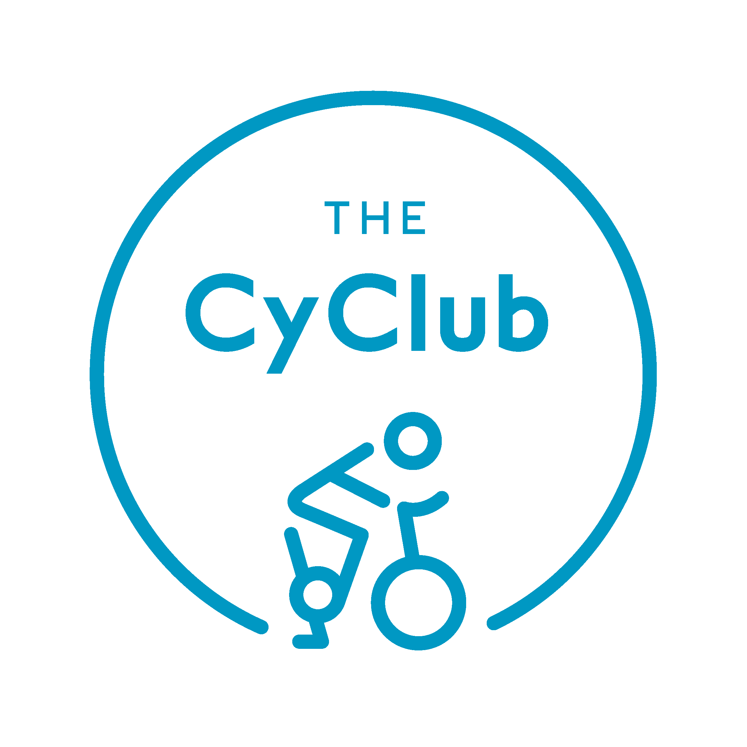

TIMETABLE Aug 1 - 7

Classes are subject to change or cancellation
MON 1st | TUES 2nd | WED 3rd | THURS 4th | FRI 5th | SAT 6th | SUN 7th
6:30  Spin with Danny |  |  |  | 6:30  Spin with Danny  (Lavinia to Cover)
 | 9:45  Spin with Hils | 9:30  Spin with Hils | 9:15  Spin with Ana | 8:15  Spin with Charley | 9:00  Spin with Ana | 9:00  Spin with Ana
10:00  Spin with Mylene  (Hils to Cover) |  |  |  | 10:15  Spin with Hils | 10:00  Spin with Ana | 10:00  Spin with Hils
 | 11:00  BEGINNERS  Spin with Hils |  | 18:00  TEEN  Spin with Charley |  | 11:00  BEGINNERS  Spin with Hils | 11:15  BEGINNERS  Spin with Hils
18:30  Spin with Hils | 19:15  VIBE  Spin with Jude | 18:30  Spin with Hils

TIMETABLE Aug 1 - 7

Classes are subject to change or cancellation
MON 1st | TUES 2nd | WED 3rd | THURS 4th | FRI 5th | SAT 6th | SUN 7th
6:30  Spin with Danny |  |  |  | 6:30  Spin with Danny  (Lavinia to Cover)
 | 9:45  Spin with Hils | 9:30  Spin with Hils | 9:15  Spin with Ana | 8:15  Spin with Charley | 9:00  Spin with Ana | 9:00  Spin with Ana
10:00  Spin with Mylene  (Hils to Cover) |  |  |  | 10:15  Spin with Hils | 10:00  Spin with Ana | 10:00  Spin with Hils
 | 11:00  BEGINNERS  Spin with Hils |  | 18:00  TEEN  Spin with Charley |  | 11:00  BEGINNERS  Spin with Hils | 11:15  BEGINNERS  Spin with Hils
18:30  Spin with Hils | 19:15  VIBE  Spin with Jude | 18:30  Spin with Hils

BENEFITS
- Instructors have their own styles and music and all are passionate about spinning!
- Suitable for all ages above 16 (under 16 sign waiver please)

- Suitable for all fitness levels. 3 Beginners Classes!

- Reserve your place weeks in advance online/mobile/phone
- 12-hour Cancellation Policy for a credit if you can’t make it

HOW TO BOOK
- Download MindBody app, search for The CyClub (using the magnifying glass) & click on Schedule OR
- Go to the MindBodyOnline.com website and do the same OR
- Send an email to info@the-cyclub OR
- Call Klara (07507652813), Hils (07977563958)
or Sharon (07817710026)

Note: You must be physically fit to participate and not have had surgery in the last 6 months.
Please tell your instructor before the class begins if you have any injuries or health conditions which may affect your ability.

45 The Market Place, Falloden Way, London, NW11 6JT
Facebook: www.facebook.com/TheCyClub & The CyClub Community | Twitter: @the_CyClub | Instagram: @the_CyClub

BENEFITS
- Instructors have their own styles and music and all are passionate about spinning!
- Suitable for all ages above 16 (under 16 sign waiver please)

- Suitable for all fitness levels. 3 Beginners Classes!
- Reserve your place weeks in advance online/mobile/phone
- 12-hour Cancellation Policy for a credit if you can’t make it
HOW TO BOOK
- Download MindBody app, search for The CyClub (using the magnifying glass) & click on Schedule OR
- Go to the MindBodyOnline.com website and do the same OR
- Send an email to info@the-cyclub OR
- Call Klara (07507652813), Hils (07977563958)
or Sharon (07817710026)

Note: You must be physically fit to participate and not have had surgery in the last 6 months.
Please tell your instructor before the class begins if you have any injuries or health conditions which may affect your ability.

45 The Market Place, Falloden Way, London, NW11 6JT
Facebook: www.facebook.com/TheCyClub & The CyClub Community | Twitter: @the_CyClub | Instagram: @the_CyClub

